Design of High Pass Filter using Windowing Techniques
5.3. Generate the coefficients of an FIR High-Pass filter using Hanning windowing techniques
Program(MATLAB Code)
clc; clear; close all;
%% --- Input Parameters ---
fp = 1000; % High-pass cutoff frequency (Hz)
fs = 8000; % Sampling frequency (Hz)
N = 50; % Filter order
wc = fp/(fs/2); % Normalized cutoff (0–1)
%% --- FIR High Pass using Hanning Window ---
b_hann = fir1(N, wc, 'high', hanning(N+1));
disp('--- High-Pass Coefficients (Hanning Window) ---');
disp(b_hann');
%% --- Frequency Response Plots ---
figure;
freqz(b_hann,1);
title('High-pass FIR using Hanning Window');

Output
--- High-Pass Coefficients (Hanning Window) ---
-0.0000
0
0.0003
0.0008
0.0009
0
-0.0020
-0.0038
-0.0035
0
0.0057
0.0100
0.0087
0
-0.0127
-0.0216
-0.0183
0
0.0267
0.0464
0.0410
0
-0.0726
-0.1568
-0.2243
0.7500
-0.2243
-0.1568
-0.0726
0
0.0410
0.0464
0.0267
0
-0.0183
-0.0216
-0.0127
0
0.0087
0.0100
0.0057
0
-0.0035
-0.0038
-0.0020
0
0.0009
0.0008
0.0003
0
-0.000

Fig
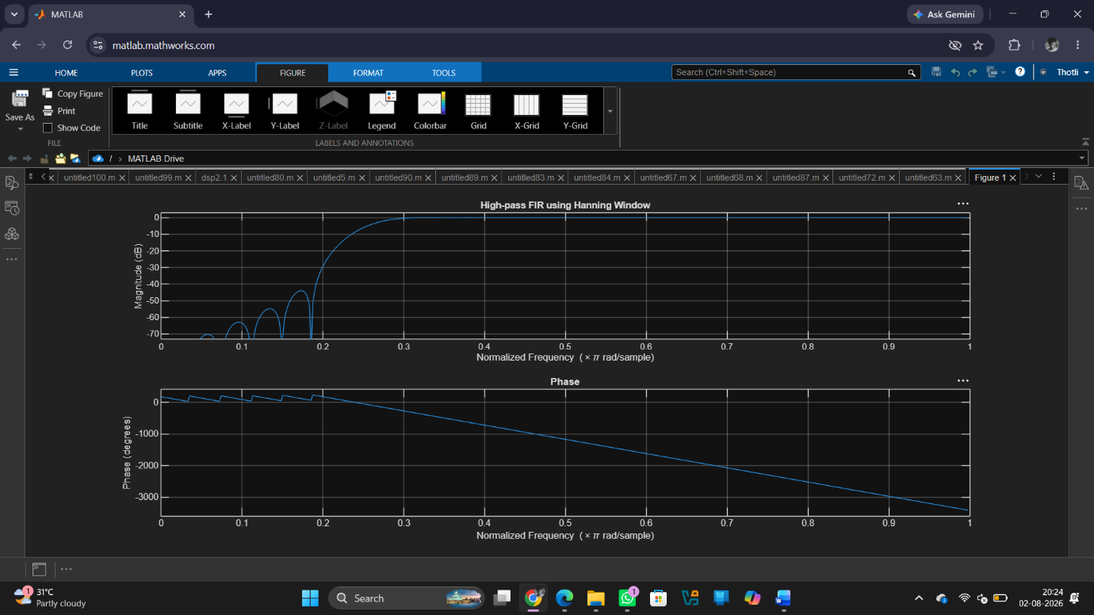

Result
1. The FIR High-Pass Filter was successfully designed using the Hanning Window technique for the specified cutoff frequency, sampling frequency, and filter order.
2. The FIR filter coefficients were successfully generated using MATLAB and the designed filter was implemented.
3. The magnitude response and phase response of the designed FIR High-Pass Filter were obtained and analysed. The magnitude response exhibited attenuation of low-frequency components and passage of high-frequency components, confirming the desired high-pass filtering characteristics. The phase response demonstrated the expected linear-phase behaviour of the FIR filter.

